CONCISE NOTE OF LECTURE 2- FUNCTION

Relations vs. Functions
A relation is just a relationship between x- and y-coordinates that means two variables or two equations.
Example 1: y²=x
Example 2: If we consider two set like, A= {1,5} and B={3,4}
Then the product of the two sets are A×B= {(1,3), (1,4) (5,3) (5,4)} and the order should be (x,y). But if we say that x>y then the product answer should be A×B= { (5,3) (5,4)}. So relation depends on the given condition.
In the set of everything that is a relation, there's a smaller subset which we call functions.
A function tries to define these relationships. It tries to give the relationship a mathematical form. An equation is a mathematical way of looking at the relationship between concepts or items. These concepts or items are represented by what are called variables.
Example: y=x+3
A variable represents a concept or an item whose magnitude can be represented by a number, i.e. measured quantitatively. Variables are called variables because they vary, i.e. they can have a variety of values. Thus a variable can be considered as a quantity which assumes a variety of values in a particular problem. Many items in economics can take on different values. Mathematics usually uses letters from the end of the alphabet to represent variables.
Example1: Set variable A={2, 6, 8, 10} so the value of a set is 2 , 6, 8 and 10 which is changeable.
Example2: Equation Variable Y=X+3, Here Y and X is two variable and Y is changeable for the all distinct value of X.

Domain:
The “domain” of a function or relation is:
- the set of all values for which it can be evaluated
- the set of allowable “input” values
- the values along the horizontal axis for which a point can be plotted along the vertical axis

Example 1:
• The set "A" is the Domain,
• The set "B" is the Codomain,
• And the set of elements that get pointed to in B (the actual values produced by the function) are the Range, also called the Image.
And we have:
- Domain: {1, 2, 3, 4}
- Codomain: {1, 2, 3, 4, 5, 6, 7, 8, 9, 10}
- Range: {3, 5, 7, 9} 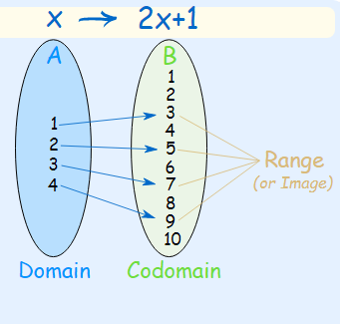
Example 2: a simple function like f(x) = x² can have the domain (what goes in) of just the counting numbers {1,2,3,...}, and the range will then be the set {1,4,9,...}

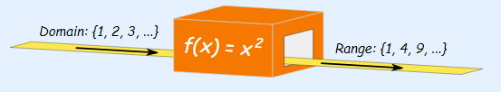

And another function g(x) = x² can have the domain of integers {...,-3,-2,-1,0,1,2,3,...}, in which case the range is the set {0,1,4,9,...}
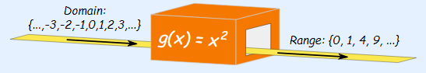

Range
The “range” of a function or relation is:
- the set of all values that it can produce
- its “output” set of values
- the set of values along the vertical axis for which a point can be plotted on its graph

Codomain
The “codomain” of a function or relation is a set of values that includes the Range as described above, but may also include additional values beyond those in the range.
Codomains can be useful when:
- You need to restrict the output of a function. For example, by specifying a codomain to be “the set of positive Real numbers”, you are instructing any who use the function to ignore any negative values it produces.
- The Range might be difficult to specify exactly, but a larger set of numbers that includes the entire Range can be specified. For example, a codomain could specify the set of all positive Real numbers, even though the function does not generate all possible positive Real numbers.
- More examples are given below:
Example1:
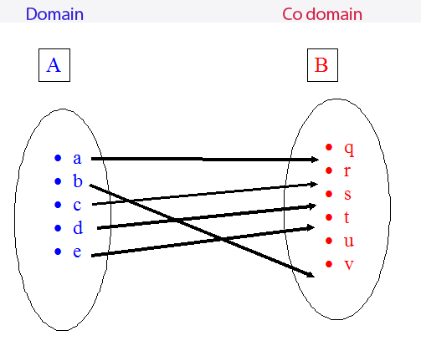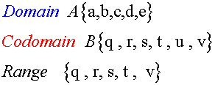
Example:2
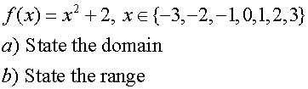
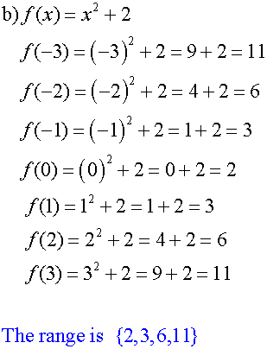
Example 3:
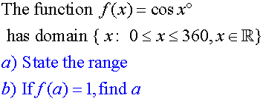

Example 4:
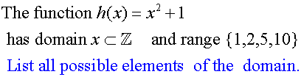
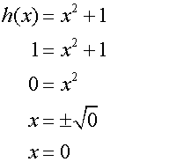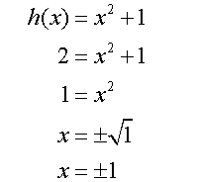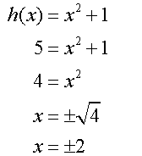

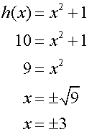

How to Find the Domain of a Rational Function: Examples with Solutions

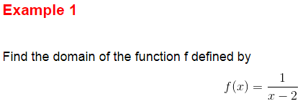
f(x) can take real values if the denominator of f(x) is NOT ZERO because division by zero is not allowed in mathematics
x - 2 ≠ 0
Solve the above inequality for to obtain the domain: x ≠ 2
Which in interval form may be written as follows
(-∞ , 2) ∪ (2 , +∞)

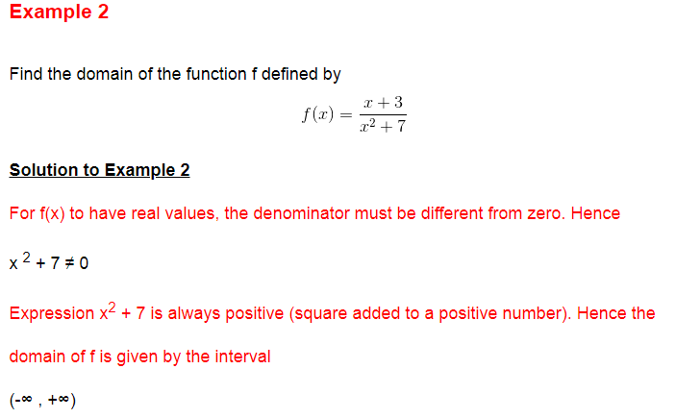
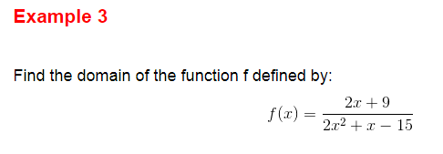
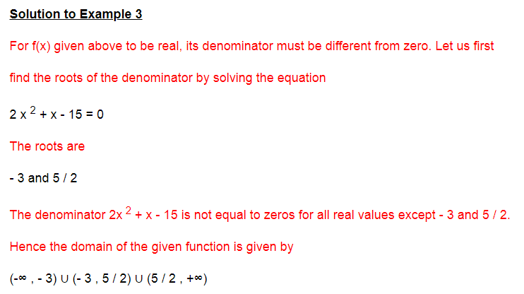
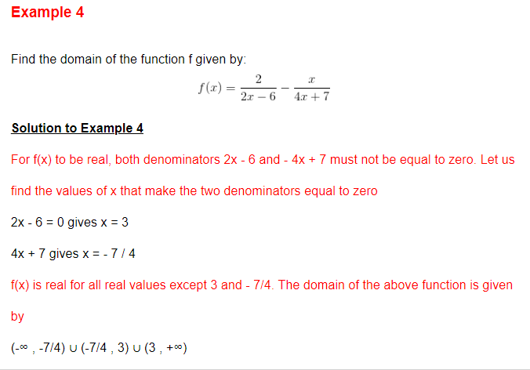

Examples on How to Find the Domain of Square Root Functions with Solutions

Example 1
Find the domain of function f defined by
f(x) = √(x - 1)

Solution to Example 1
- For f(x) to have real values, the radicand (expression under the radical) of the square root function must be positive or equal to 0. Hence
x - 1 ≥ 0
- The solution set to the above inequality is the domain of f(x) and is given by: x ≥ 1
or in interval form [1 , +∞)

Example 2
Find the domain of function f defined by
f(x) = √ [ (x - 2)(x + 3) ]

Solution to Example 2
- For f(x) to have real values, the radicand (x - 2)(x + 3) must be positive. Hence
(x - 2)(x + 3) ≥ 0
- Solve the above inequality to obtain the solution set, which is also the domain, in interval form as follows:
(-∞ , -3] ∪ [2 , + ∞)

Example 3
Find the domain of function f defined by:
f(x) = √ [ x² + 2 x - 1 ]

Solution to Example 3
- For √ [ x² + 2 x - 1 ] to be real, the radicand must be positive or equal to 0. Hence the inequality
x² + 2x - 1 ≥ 0
- The solution set of the above inequality, which is also the domain, is given in interval form as follows:
(-∞ , -1-√2] ∪ [-1+ √2 , + ∞)
- The domain of the given function is given by the interval (-∞ , -1-√2] ∪ [-1+ √2 , + ∞).

Example 4
Find the domain of function f defined by:
f(x) = √[ (2x - 1)/(x + 3) ]

Solution to Example 4
- The domain of this function is the set of all values of x such that (2x - 1)/(x + 3) ≥ 0 which is an inequality to solve. The solution set of the above inequality which is also the domain is given by
(-∞ , -3) U [ 1 / 2 , +∞)
Domain and Range of Logarithmic Functions
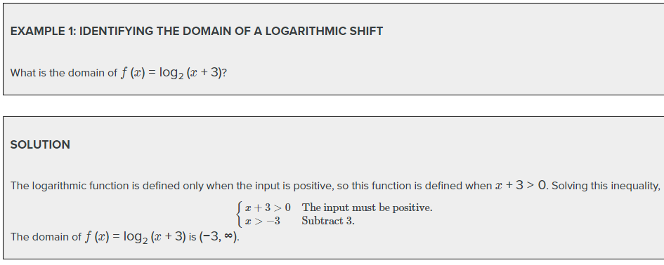
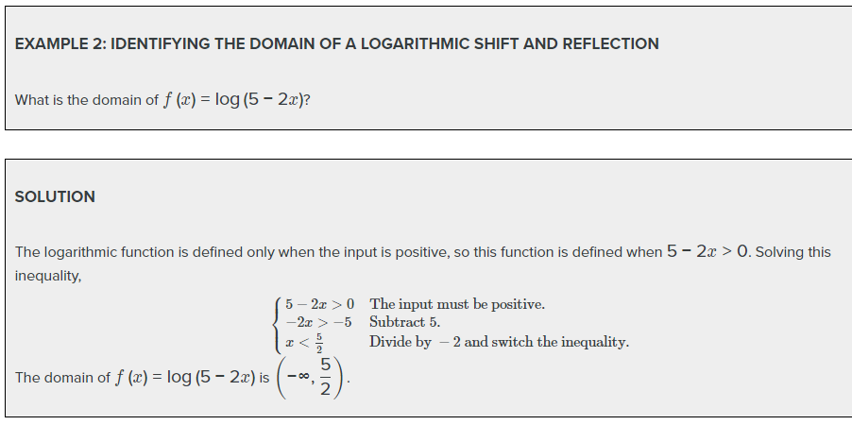

When we call relation as a function?
Example 1
Problem | Is the relation given by the set of ordered pairs below a function?  {(−3, −6),(−2, −1),(1, 0),(1, 5),(2, 0)}
 | x y  −3 −6  −2 −1  1 0  1 5  2 0 | Organizing the ordered pairs in a table can help.  By definition, the inputs in a function have only one output.  The input 1 has two outputs: 0 and 5.
Answer | The relation is not a function.

Example 2
Problem | Is the relation given by the set of ordered pairs below a function?  {(−3, 4),(−2, 4),( −1, 4),(2, 4),(3, 4)}
 | x y  −3 4  −2 4  −1 4  2 4  3 4 | You could reorganize the information by creating a table.
 | Each input has only one output. | Each input has only one output, and the fact that it is the same output (4) does not matter.
Answer | This relation is a function.
Identify Function from a graph:

The vertical line test can be used to determine whether a graph represents a function. If we can draw any vertical line that intersects a graph more than once, then the graph does not define a function because a function has only one output value for each input value.
